|  |  |  |
| --- | --- | --- |
| ***Term*** | ***Definitions*** | ***Examples*** |
| **Function** | **A function** is a relation for which each value form the set the first components of the ordered pairs is associated with exactly one value from the set of second components of the ordered pair.  (There is exactly one X value that goes to one Y value)  **Working definition:** A function is an equation for which any x that can be plugged into the equation will yield exactly one y out of the equation.  (A relation in which each element of the domain is paired with **exactly one** element from the range.) |  |
| **Relation:** | Set of ordered pairs, (X, Y) |  |
| **Notation:** | |  |  |  |  | | --- | --- | --- | --- | | ***Graph*** | ***Set Notation*** | ***Interval Notation*** | ***Number*** | | Open circles | <, > | ( ) | Does NOT include number | | Closed Circles | ≤, ≥ | [ ] | Includes number |   **Interval Notation:**  **Set-Builder Notation:**  {Expression: Rules} Example: $\{x:xϵR\}$ |  |
| **Domain** | The set of all x – coordinates of the ordered pairs of a relation |  |
| **Range** | The set of all y-coordinates of the ordered pairs of a relation |  |
| **Parent Functions** | |  |  | | --- | --- | | ***Parent Function*** | ***Graph*** | | **Linear: $y=x$**  Domain: $(-∞, ∞)$ Range: ( $-∞, ∞)$ End Behavior:  Odd | ... link, and then click graph. This is the linear parent function | | **Quadratic: $y=x^{2}$**  Domain: $(-∞, ∞)$ Range: [0 $, ∞)$ End Behavior:    Even | https://sp.yimg.com/ib/th?id=HN.608036776646804501&pid=15.1&P=0 | | **Absolute Value:**  Domain: $(-∞, ∞)$ Range: ( $[0, ∞)$ End Behavior:  Even | Absolute Value Functions | | **Radical, Square Root $$y=\sqrt{x}$$**  Domain: $[0, ∞)$ Range: [0 $, ∞)$ End Behavior: $x→∞, y→∞$   Neither | https://sp.yimg.com/ib/th?id=HN.607996438314616557&pid=15.1&P=0 | | **Constant: $y=C$**  Domain: $(-∞, ∞)$ Range: ( $\{y:y=C\}$ End Behavior:  Even | https://sp.yimg.com/ib/th?id=HN.608032683546512558&pid=15.1&P=0 | | **Cubic:**  Domain:  Range: ( $-∞, ∞)$ End Behavior:  Odd | Cubic Parent Graph | | **Exponential: $$y=b^{x}, b>1$$**  Domain: $(-∞, ∞)$ Range: (0 $, ∞)$ End Behavior: $x→-∞, y→0$ $$x→-∞, y→∞$$  Neither | https://sp.yimg.com/ib/th?id=HN.608031468065718666&pid=15.1&P=0 | |  |
| **Function intervals** | 1. **Increasing Functions:**  * When y-value increases as the x-value increases.  1. **Decreasing Functions**:  * When the y-value decreases as the x-value increases.  1. **Positive & Negative functions:**  * Linear: If M is positive * Quadratic: If A is positive  1. **Relative Maxima & Minima: (Extremes or Extrema)**  * Maximum: $f\left(a\right)≥f\left(x\right)forall x in the interval$* Minimum:  1. **Symmetry: Odd or Even graphs** 2. *Even Functions*: $f\left(x\right)=f\left(-x\right)for all x$ * There is symmetry about the y-axis (like a reflection)  1. *Odd Functions*: $-f\left(x\right)=f\left(-x\right)for all x$ * Origin symmetry (symmetry is about the origin)  1. *Neither (Odd nor Even)*  * Its not odd nor even function  1. *Tests for Symmetry*:  * A graph will have symmetry about the x-axis if we get an equivalent equation when all the y’s are replaced with –y. * A graph will have symmetry about the y-axis if we get an equivalent equation when all the x’s are replaced with –x. * A graph will have symmetry about the origin if we get an equivalent equation when all the y’s are replaced with –y and all the x’s are replaced with –x.   **6. End Behaviors**: Is the behavior of the graph of f(x) as x approaches positive infinity or negative infinity. |  |

Set Notation:

[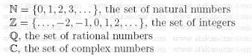](http://www.google.com/url?sa=i&rct=j&q=&esrc=s&frm=1&source=images&cd=&cad=rja&uact=8&docid=lbX1R-kp3GJUuM&tbnid=q8urEvmA-AIAWM:&ved=0CAcQjRw&url=http://atakanozar.net/sf04i002.asp&ei=V74yVOG4OoqPNru6gMgI&bvm=bv.76802529,d.aWw&psig=AFQjCNFJjJN226rFOMDR7gCsTBFSwMqISA&ust=1412697918926492)[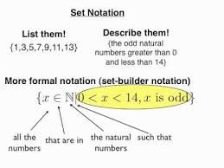](http://www.google.com/imgres?imgurl=http://i.ytimg.com/vi/lZuwL-AvEsc/hqdefault.jpg&imgrefurl=http://www.youtube.com/watch?v%3DlZuwL-AvEsc&h=360&w=480&tbnid=4WgIrtG_cLxJxM:&zoom=1&docid=SH1s5Q9iGY8zdM&ei=vr0yVKrkLIi3yATO0oGQBw&tbm=isch&ved=0CGIQMyglMCU&iact=rc&uact=3&dur=494&page=4&start=36&ndsp=17)

**End Behaviors:**

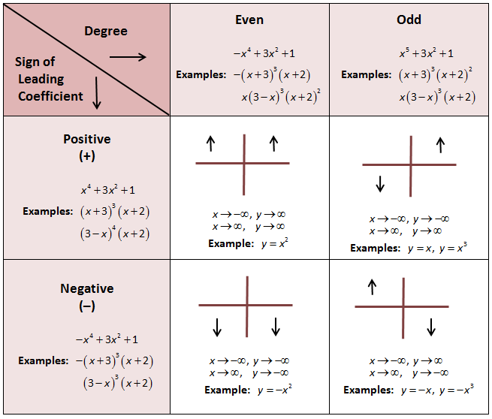

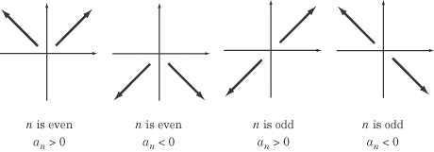

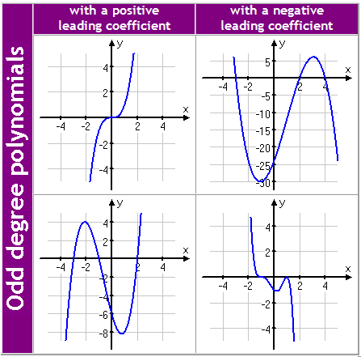 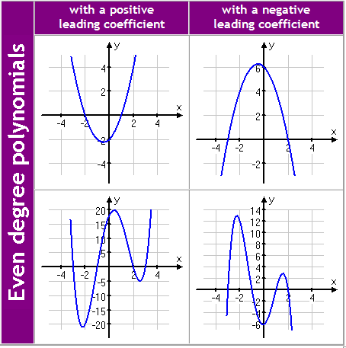

**Symmetries:**

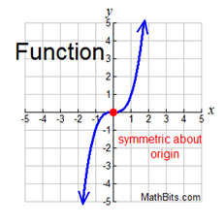 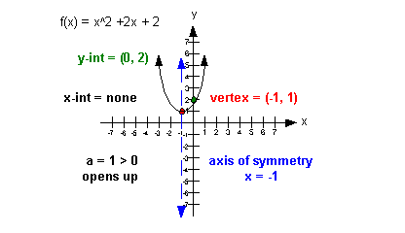

**Relative Maxima & Minima:**

